**GIT BRANCHING:**

1. First, we make a folder Gitproject2 Inside C drive -> inside that folder we make directory ecommerceProj inside it on master branch we create one index.txt.
2. Will Git add and commited this file on staging and local directory area.
3. After that we created one branch login_feature  
   using cmd - **> GIT BRANCH LOGIN_FEATURE**
4. After that will Checkout login_feature branch using **GIT CHECKOUT LOGIN_FEATURE** and will create a new folder with MKDIR LOGIN inside it will create file login.txt and will Will Git add and commited this file on staging and local directory area.
5. 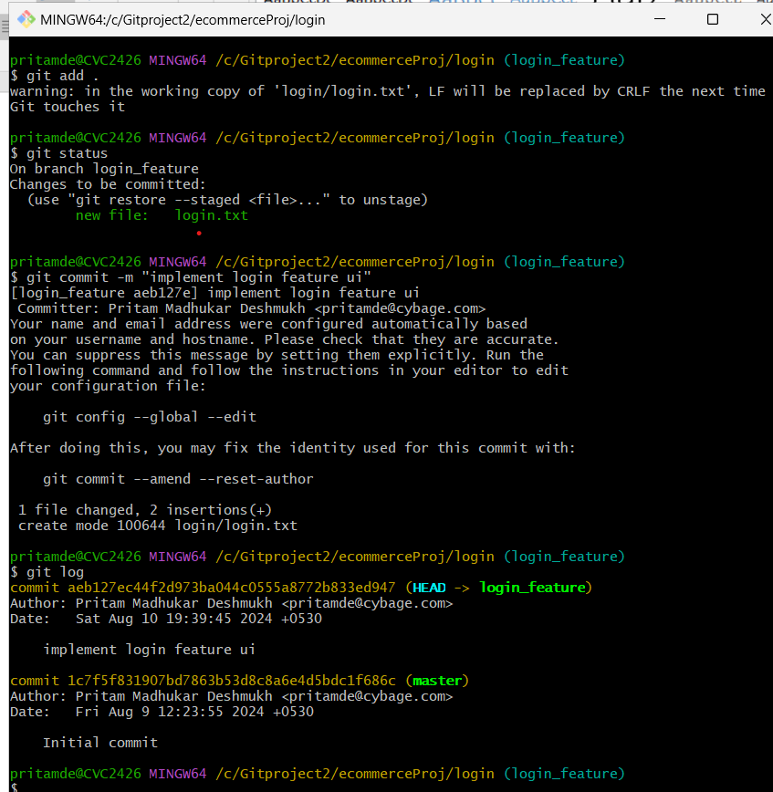
6. So we can see one commit is on master and another in login_feature branch

**GIT RENAME BRANCH AND DELETING**

First we create new branch named dummy_branch,

We can rename out git branch using   
**GIT BRANCH –m “BRANCHNAME”(NEW_BRANCH)**

And we can delete our branch using   
**GIT BRANCH –d “BRANCHNAME”(NEW_BRANCH)**

